|  |
| --- |
| Logbook for ISD |
| Your name and student number |
|  |
|  |
|  |

Logbook for ISD

Your name and student number

Contents

Introduction 2

Week 1 3

Exercises 1 3

Exercises 2 3

Exercises … 3

Week 2 4

Exercises 1 4

Exercises 2 4

Exercises … 4

Week 3 5

Exercises 1 5

Exercises 2 5

Exercises … 5

Week…13 6

Exercises 1 6

Exercises 2 6

Exercises … 6

# Introduction

A brief introduction to what you have done within the module and how your experience was with the exercises and the overall module. Probably up to half a page.

# Week 1

Some overview of the topics covered by the lecture and the exercises. Not too much, may be a paragraph.

## Exercises 1

Provide the exercises description and your answers. Where applicable use source code excerpts, explanations of these, represent your results, for example by showing screenshots of your program and, where applicable, display the use of your code repository (github) either by screenshots or by providing log data from your code repository.

## Exercises 2

Provide the exercises description and your answers. Where applicable use source code excerpts, explanations of these, represent your results, for example by showing screenshots of your program and, where applicable, display the use of your code repository (github) either by screenshots or by providing log data from your code repository.

## Exercises …

# Week 2

Some overview of the topics covered by the lecture and the exercises. Not too much, may be a paragraph.

## Exercises 1

1) Write an algorithm that describes how to make scrambled eggs, try to use

control words, like IF, WHEN, UNTIL, WHILE, WAIT, AND, OR.

1. Get cup
2. Put water in cup
3. Leave water in cup until be clear
4. add some sugar **If** the water is cold
5. Hold for 7minutes
6. While you waiting, after 7 minutes grip the orange juice flavour
7. Put some orange flavour in cup
8. Add Ice to the cup
9. Roll the cup with spoon for 3 minutes
10. Then drink the orange juice

## Exercises 2

Is Idle (the Python language shell) an Interpreter or an Compiler or both?

Explain your answer.

CPU understands only machine language instruc4ons

Programs that are written in a high-level language must be

translated into machine language

Depending on the language that a program has been written in, the

programmer will use either a compiler or an interpreter to make the

transla4on.

## Exercises 3

Write a command in the Idle shell that says “Hello world

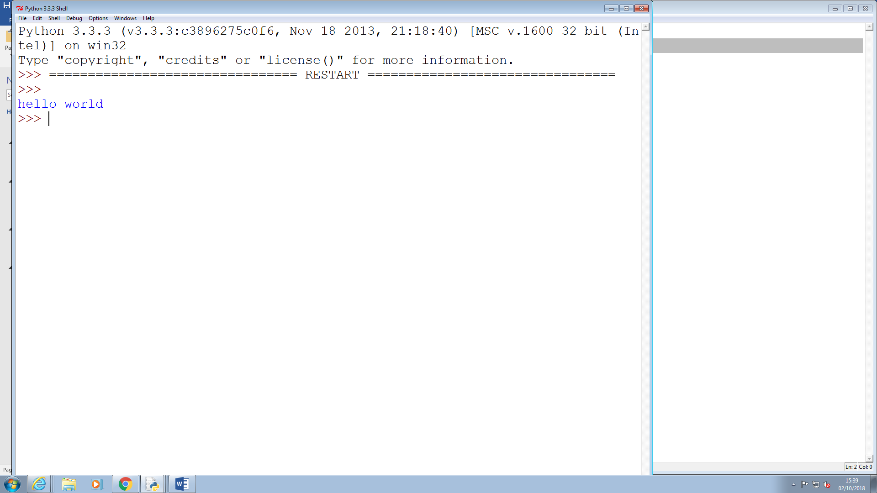

# Exercises 4

4) Write a program that produces the following output:

Hello World

I am in my ISD class right now

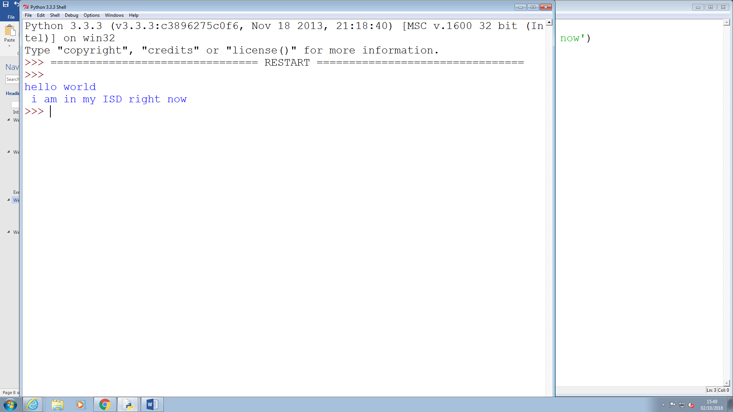

# Exercises 5

5) Write a program that asks the user for his/her name and produces an output

like:

Hi there, what is your name?

>User input to be read<

Hello

“User name”

How are you?

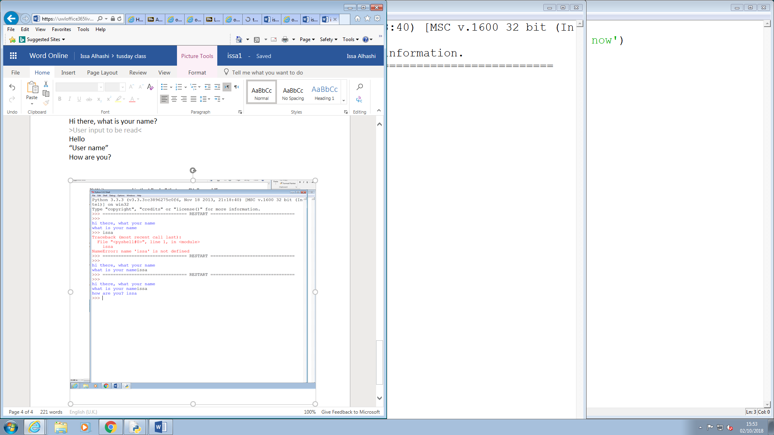

# Week 3

Some overview of the topics covered by the lecture and the exercises. Not too much, may be a paragraph.

## Exercises 2

* 1. 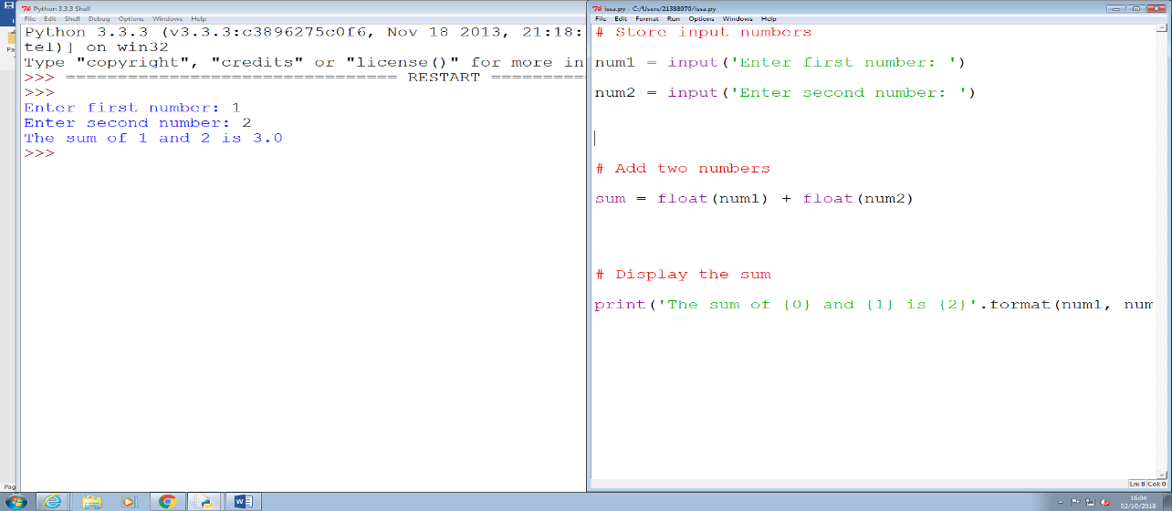Write a program that asks for two numbers (Python has all the basic mathematical functions in place, like +,- etc.), adds them up and displays the result.

2) Answer the questions by implementing the code and run it.

1. a) What will the output be from the following code?

num = 4

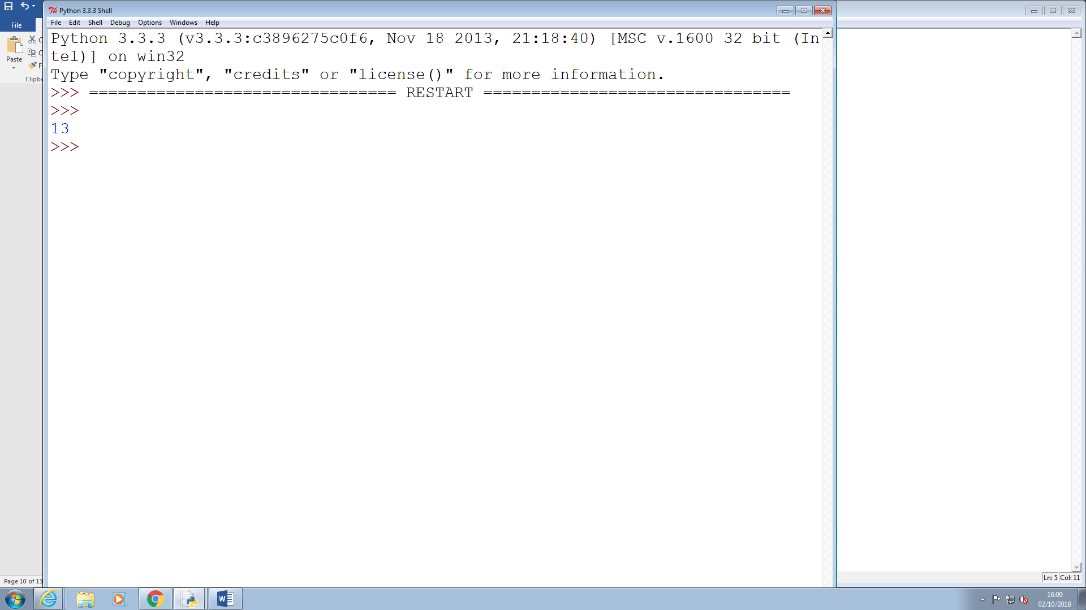

## Exercises 2

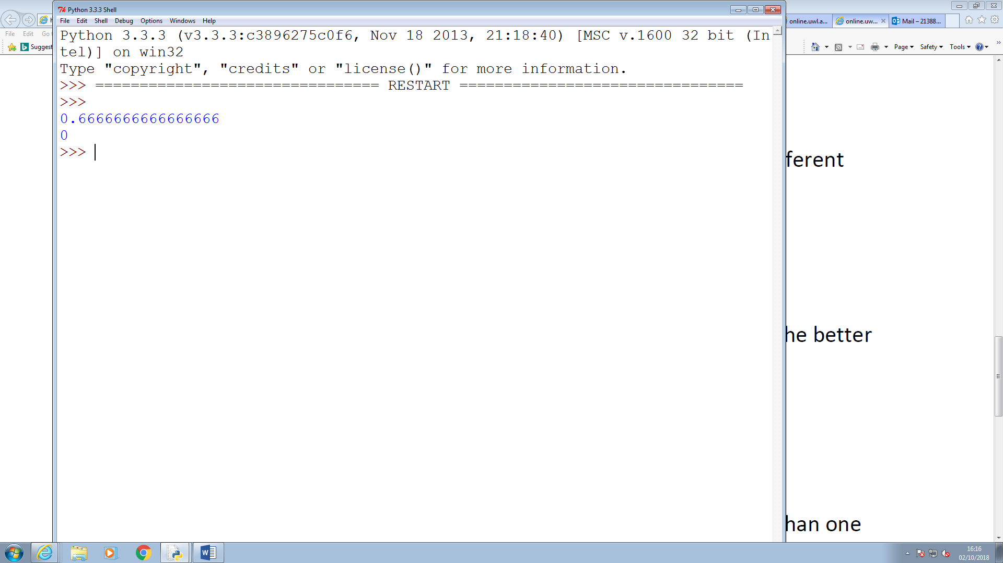

Single number

Is show the decimal point

## Exercises 3

## AreaOfRectangle: Is better one to was because is using camel case which were the first letter variable lower case and the word start with up case letter

## Exercises 4

apple APPLE Apple2 1Apple account number account_number account.number accountNumber fred Fred return return_value 5Return GreatBigVariable greatBigVariable great_big_variable great.big.variable

the highlight is not allowed because everything start with number or start with caplet letter is can’t be used or can’t be accepted.

# Week4

## Exercises 1

1. Explain the mistake in the following code:

radius = input("Radius:")

x = 3.14

pi = x

area = pi * radius ** 2

the error code between the number 2

## Exercises 2

x = 4

y = 5

## a = 3(x + y)

the code mistake between number 3

## Exercises 3

Explain the mistake in the following code:

radius = input (float ("Enter the radius:"))

The mistake is the float meant to be before the input.

## Exercises 3

Why does this code not calculate the average?

print (3 + 4 + 5) / 3

The brackets in wrong place.

## Exercises 3

Consider the following code:

x = 19.93

y = 20.00

z = y – x

print(z)

The output is 0.0700000000028 Why is that so?

Improve the code so that the output is to two decimal places.

Answer ? “%.2f”

Example description of an exercise:

